

# 

### Semester Two Examination, 2018

### Question/Answer booklet

# MATHEMATICS

**APPLICATIONS**

**UNITS 3 AND 4**

## Section Two:

## Calculator-assumed

|  |  |  |  |  |  |  |  |  |  |  |
| --- | --- | --- | --- | --- | --- | --- | --- | --- | --- | --- |
| Student number: In figures |  |  |  |  |  |  |  |  |  |  |

In words

Your name

## Time allowed for this section

Reading time before commencing work: ten minutes

Working time: one hundred minutes

## Materials required/recommended for this section

***To be provided by the supervisor***

This Question/Answer booklet

Formula sheet (retained from Section One)

***To be provided by the candidate***

Standard items: pens (blue/black preferred), pencils (including coloured), sharpener,  
correction fluid/tape, eraser, ruler, highlighters

Special items: drawing instruments, templates, notes on two unfolded sheets of A4 paper, and up to three calculators approved for use in this examination

## Important note to candidates

No other items may be taken into the examination room. It is **your** responsibility to ensure that you do not have any unauthorised material. If you have any unauthorised material with you, hand it to the supervisor **before** reading any further.

## Structure of this paper

|  |  |  |  |  |  |
| --- | --- | --- | --- | --- | --- |
| Section | Number of questions available | Number of questions to be answered | Working  time (minutes) | Marks available | Percentage of examination |
| Section One:  Calculator-free | 7 | 7 | 50 | 51 | 35 |
| Section Two:  Calculator-assumed | 12 | 12 | 100 | 99 | 65 |
|  | | |  | **Total** | 100 |

## Instructions to candidates

1. The rules for the conduct of examinations are detailed in the school handbook. Sitting this examination implies that you agree to abide by these rules.

2. Write your answers in this Question/Answer booklet.

3. You must be careful to confine your response to the specific question asked and to follow any instructions that are specified to a particular question.

4. Supplementary pages for the use of planning/continuing your answer to a question  
have been provided at the end of this Question/Answer booklet. If you use these pages to continue an answer, indicate at the original answer where the answer is continued, i.e. give the page number.

5. Show all your working clearly. Your working should be in sufficient detail to allow your answers to be checked readily and for marks to be awarded for reasoning. Incorrect answers given without supporting reasoning cannot be allocated any marks. For any question or part question worth more than two marks, valid working or justification is required to receive full marks. If you repeat any question, ensure that you cancel the answer you do not wish to have marked.

6. It is recommended that you do not use pencil, except in diagrams.

7. The Formula sheet is not to be handed in with your Question/Answer booklet.

Section Two: Calculator-assumed 65% (99 Marks)

This section has**twelve (****12)** questions. Answer **all** questions. Write your answers in the spaces provided.

Working time: 100 minutes.

Question 8 (6 marks)

The deseasonalised number of working holiday makers in Australia over the four-year period from March 2014 to December 2017 was modelled by $n=160.74-1.382t$, where $n$ is the number of people in thousands and $t$ is the quarter, with $t=1$ corresponding to March 2014.

The Seasonal Index table is shown below.

|  |  |  |  |  |
| --- | --- | --- | --- | --- |
| Quarter | March | June | September | December |
| Seasonal Index | $$1.07$$ | $$x$$ | $$0.96$$ | $$1.02$$ |

(a) Determine the value of $x$ in the table above. (1 mark)

(b) State, with reasons, whether the number of working holiday makers in Australia was highest during September 2017 or during September 2014. (2 marks)

(c) Use your knowledge of time series to estimate the actual change in the number of working holiday makers in Australia from December 2017 ( $t=16)$ to March 2018 ($t=17)$.

(3 marks)

Question 9 (6 marks)

(a) A connected planar graph has $11$ faces and $7$ vertices. Determine how many edges must be removed from the graph to leave the minimum spanning tree. (3 marks)

(b) The vertices in the graph below represent activity centres in a theme park and the edges represent various footpaths between the centres. The weights on the edges represent the time to travel along that footpath. Identify the minimum spanning tree on the graph and state its length. (3 marks)

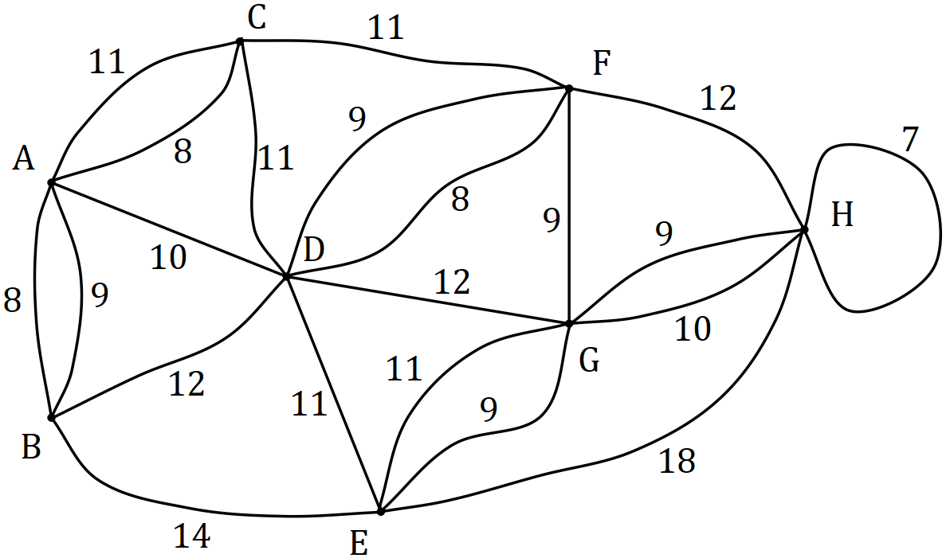

Question 10 (8 marks)

The data in the table below was collected by a student who was investigating whether an association exists between a person's hair and eye colour. The observations were taken from a survey of $64$ people.

|  |  |  |  |
| --- | --- | --- | --- |
|  |  | Eye colour | |
|  |  | Blue-Green | Brown |
| Hair colour | Black | $$0$$ | $$11$$ |
| Blond | $$16$$ | $$13$$ |
| Brown | $$4$$ | $$20$$ |

(a) What percentage of the people surveyed had brown eyes? (1 mark)

(b) What percentage of the brown eyed people had blond hair? (1 mark)

(c) Complete the table of **column** percentages below. (2 marks)

|  |  |  |  |
| --- | --- | --- | --- |
|  |  | Eye colour | |
|  | % | Blue-Green | Brown |
| Hair colour | Black | $$0$$ |  |
| Blond |  |  |
| Brown |  |  |

(d) Does the data suggest the presence of an association between the categorical variables? Justify your answer using figures from the percentage table. (2 marks)

(e) One of the conclusions made by the student was that having black hair caused a person to have brown eyes. Comment on this conclusion. (2 marks)

Question 11 (6 marks)

Spectators leave a sports ground $C$ and walk to a train station $F$ along footpaths in the directions shown on the network below. The weights on the edges represent the maximum number of people who can safely travel along each footpath, in hundreds of people per minute.

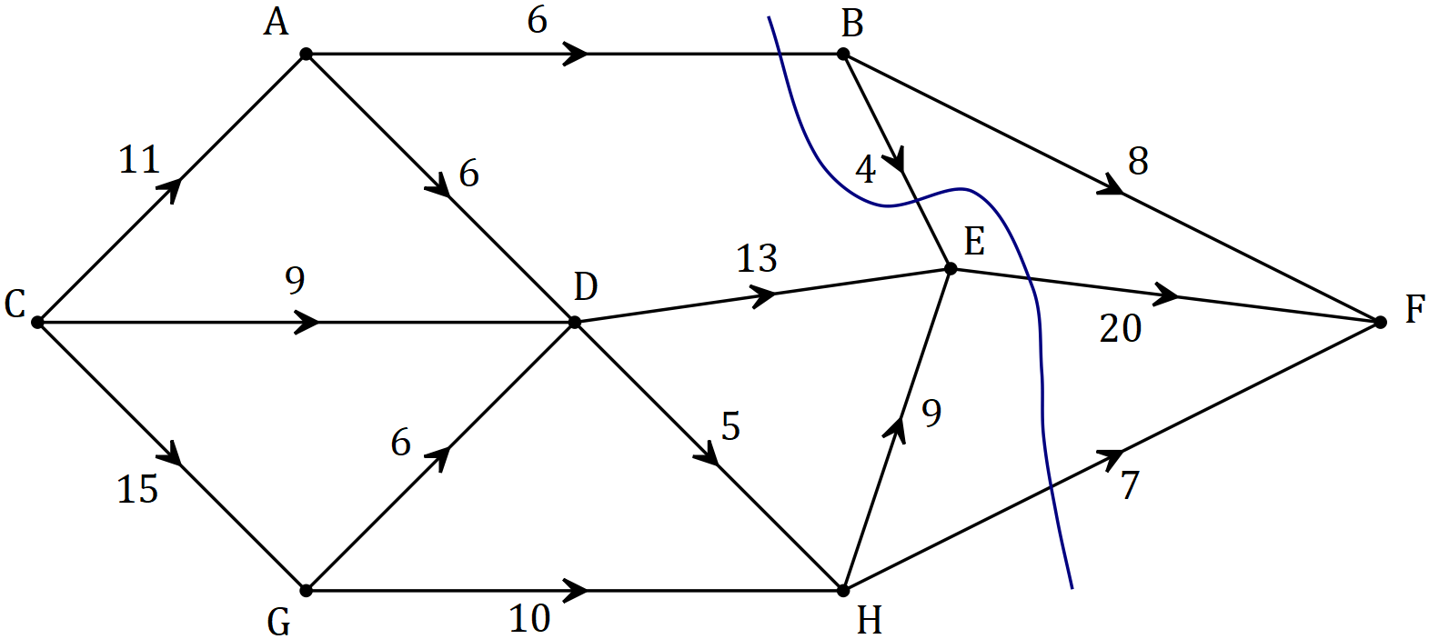

(a) By listing the different paths and their corresponding flow rates, determine the maximum number of people that can walk through the network from $C$ to $F$ every minute. (4 marks)

(b) Verify your answer from part (a) by showing the minimum cut on the network above and showing in the space below how to determine the capacity of the cut. (2 marks)

Question 12 (9 marks)

At the start of January an annuity was set up with a sum of $\$440 000$. At the end of each month, interest on the balance at the start of the month was added and then $\$3 350$ was withdrawn. The table below illustrates this process.

|  |  |  |  |  |
| --- | --- | --- | --- | --- |
| Month, $n$ | Balance at start of month, $T_{n}$ | Interest for month | Withdrawal | Balance at end of month, $T_{n+1}$ |
| $$1$$ | $$\$440 000.00$$ | $$\$2 420.00$$ | $$\$3 350.00$$ | $$\$439 070.00$$ |
| $$2$$ | $$\$439 070.00$$ | $$\$2 414.89$$ | $$\$3 350.00$$ | $$\$438 134.89$$ |
| $$3$$ | $$\$438 134.89$$ | $$\$2 409.74$$ | $$\$3 350.00$$ | $$\$437 194.63$$ |
| $$4$$ | $$\$437 194.63$$ | $$\$2 404.57$$ | $$\$3 350.00$$ | $$\$436 249.20$$ |
| $$5$$ | $$\$436 249.20$$ | $$\$2 399.37$$ | $$\$3 350.00$$ | $$P$$ |
| $$6$$ |  | $$Q$$ |  |  |

(a) Show how to use values from the table to deduce that the annual interest rate is $6.6\%$.

(2 marks)

(b) The linear recurrence relation for the balance of the annuity at the start of month $n$ has the form $T_{n+1}=aT_{n}-b, T_{1}=c$. State the values of $a$, $b$ and $c$. (2 marks)

(c) Determine the values of $P$ and $Q$ in the table. (2 marks)

(d) Determine the balance of the annuity at the end of month $120$ and calculate the total interest that the annuity has earned over the first $120$ months. (3 marks)

Question 13 (11 marks)

To investigate the hypothesis that the mass of sugar, $w$ grams, that will dissolve in $300$ ml of water changes with the temperature, $t°C$, of the water, a student collected the results shown in the table below.

|  |  |  |  |  |  |  |  |  |  |
| --- | --- | --- | --- | --- | --- | --- | --- | --- | --- |
| $$t$$ | $$25$$ | $$30$$ | $$35$$ | $$40$$ | $$45$$ | $$50$$ | $$55$$ | $$60$$ | $$65$$ |
| $$w$$ | $$254$$ | $$264$$ | $$289$$ | $$293$$ | $$319$$ | $$329$$ | $$351$$ | $$375$$ | $$393$$ |

(a) Identify the explanatory variable in this investigation. (1 mark)

(b) Calculate the correlation coefficient between temperature and mass of dissolved sugar and hence describe the direction and strength of the association between the variables.

(2 marks)

(c) Determine the equation of the least-squares line for predicting $w$ from $t$. (2 marks)

(d) Interpret, in context, the value of

(i) the $y$-intercept of the least-squares line in (c). (1 mark)

(ii) the gradient of the least-squares line in (c). (1 mark)

(e) Predict the mass of sugar that will dissolve in $300$ ml of water at a temperature of

(i) $34°C$. (1 mark)

(ii) $80°C$. (1 mark)

(f) Comment on the reliability of both predictions in (e). (2 marks)

Question 14 (11 marks)

Aya deposits a fixed sum in her bank account each week so that its balance after $n$ deposits is given by $A_{n}$, where $A_{n+1}=A_{n}+\$3.50$, $A_{1}=\$59$.

(a) Determine

(i) the balance of Aya's account after $20$ deposits. (1 mark)

(ii) the least number of deposits Aya must make so that the balance in her account exceeds $\$200$. (1 mark)

Starting at the same time as Aya, Bart withdraws a fixed sum from his bank account every week so that its balance after $n$ withdrawals is given by $B_{n}$, where $B_{n+1}=B_{n}-\$1.80$, $B_{1}=\$324$.

(b) Determine

(i) the th term rule for the balance of Bart's account after $n$ withdrawals. (2 marks)

(ii) the maximum number of withdrawals Bart can make until he has no money left.

(1 mark)

(c) Determine the value of $n$ so that $A_{n}=B_{n}$ and state the value of $A_{n}$ at this time. (2 marks)

(d) Let $C_{n}$ be the combined balance, in dollars, that Aya and Bart have in their accounts after they have made $n$ deposits and $n$ withdrawals respectively.

(i) Show that $C_{5}=\$389.80$. (1 mark)

(ii) The th term rule for $C_{n}$ is $C_{n}=an+b$. Determine the values of $a$ and $b$. (2 marks)

(iii) Determine the smallest value of $n$ for $C_{n}$ to exceed $\$525$. (1 mark)

Question 15 (8 marks)

(a) A company advertised compound interest of $15.6\%$ pa on investments of $\$250 000$ for a period of $5$ years. Calculate the total interest on the investment over this time. (2 marks)

(b) Savings account A offers interest of $4.22\%$ pa compounded monthly and savings account B offers interest of $4.23\%$ pa compounded quarterly. Calculate the effective interest rate for both accounts and hence decide which savings account offers the better return.

(3 marks)

(c) A philanthropist is considering funding $8$ scholarships to a local college. Each student in receipt of a scholarship would receive a payment of $\$6 000$ on the yearly anniversary of the creation of the fund. Determine, to the nearest $\$100$, the initial sum of money that should be deposited in an account paying interest at a rate of $3.6\%$ compounded monthly to create a perpetuity to fund all $8$ scholarships. (3 marks)

Question 16 (8 marks)

A company recorded the distance travelled, $k$ in hundreds of km, and the amount of fuel used, $f$ litres, for the trucks in its fleet each day. The scatterplot below shows the data for one day, for which $r=0.938$ and the equation of the least-squares line is $f=44.9k+17.5$.

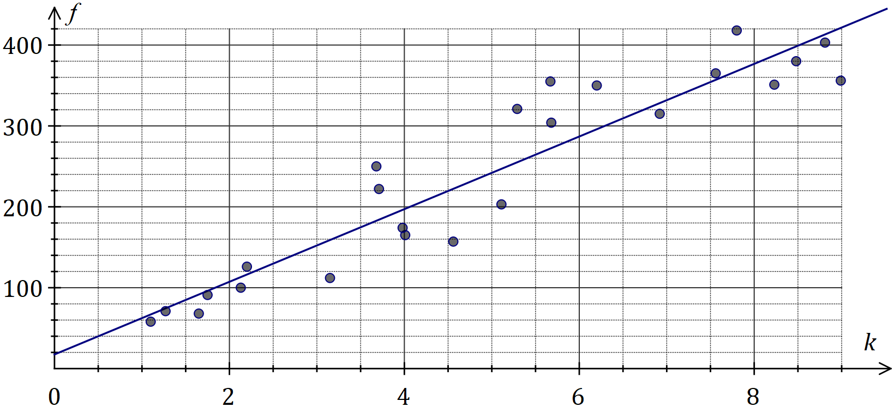

(a) What percentage of the variation in the amount of fuel used can be explained by the variation in distance travelled? (1 mark)

(b) Draw the least-squares line on the scatterplot above. (2 marks)

(c) Determine the residual for the data point $(4.56, 157)$ and add it to the residual plot below.

(3 marks)

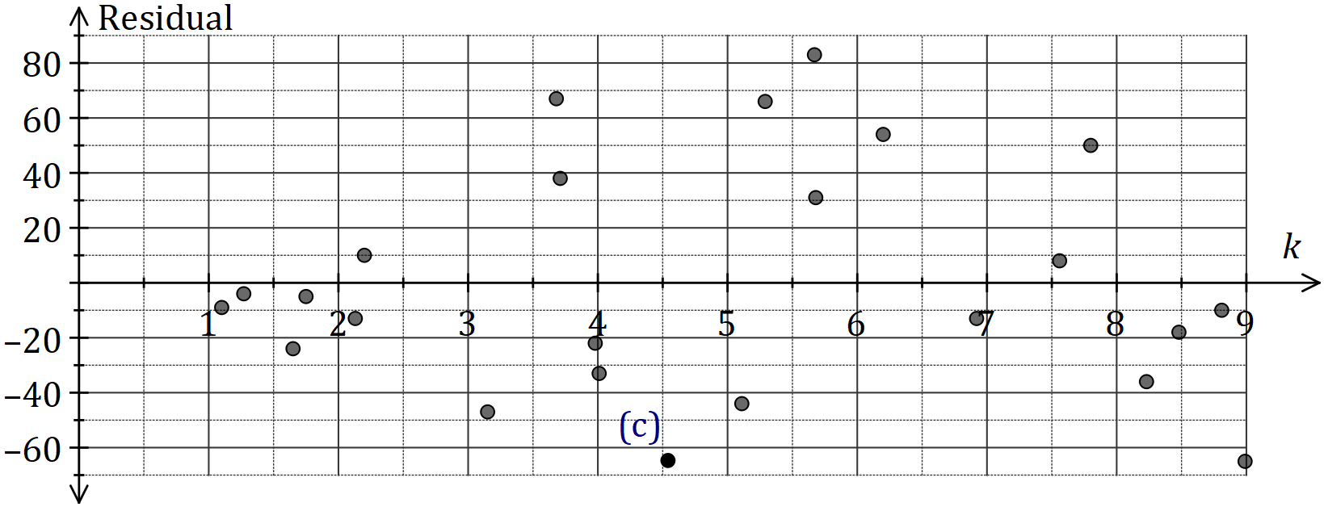

(d) Use the residual plot to comment on the appropriateness of fitting a linear model to the data. (2 marks)

Question 17 (10 marks)

The time, $T$ minutes, a new driver spent delivering goods on the same city route is shown in the table and graph below.

|  |  |  |  |  |  |  |
| --- | --- | --- | --- | --- | --- | --- |
| Week | Day | Day number ($n$) | Time  ($T$) | $3$-day mean | Percentage of $3$-day mean | Deseasonalised time ($t$) |
| $$1$$ | Fri | $$1$$ | $$90$$ |  | $$111.1$$ | $$80.8$$ |
| $$1$$ | Sat | $$2$$ | $$87$$ | $$81$$ | $$107.4$$ | $$81.9$$ |
| $$1$$ | Sun | $$3$$ | $$66$$ |  | $$81.5$$ | $$80.1$$ |
| $$2$$ | Fri | $$4$$ | $$87$$ |  | $$111.5$$ | $$78.1$$ |
| $$2$$ | Sat | $$5$$ | $$83$$ | $$A$$ | $$106.4$$ | $$78.2$$ |
| $$2$$ | Sun | $$6$$ | $$64$$ |  | $$82.1$$ | $$77.7$$ |
| $$3$$ | Fri | $$7$$ | $$85$$ |  | $$B$$ | $$76.3$$ |
| $$3$$ | Sat | $$8$$ | $$79$$ | $$76$$ | $$103.9$$ | $$74.4$$ |
| $$3$$ | Sun | $$9$$ | $$C$$ |  | $$84.2$$ | $$77.7$$ |
| $$4$$ | Fri | $$10$$ | $$79$$ |  | $$111.3$$ | $$D$$ |
| $$4$$ | Sat | $$11$$ | $$76$$ | $$71$$ | $$107$$ | $$71.6$$ |
| $$4$$ | Sun | $$12$$ | $$58$$ |  | $$81.7$$ | $$70.4$$ |

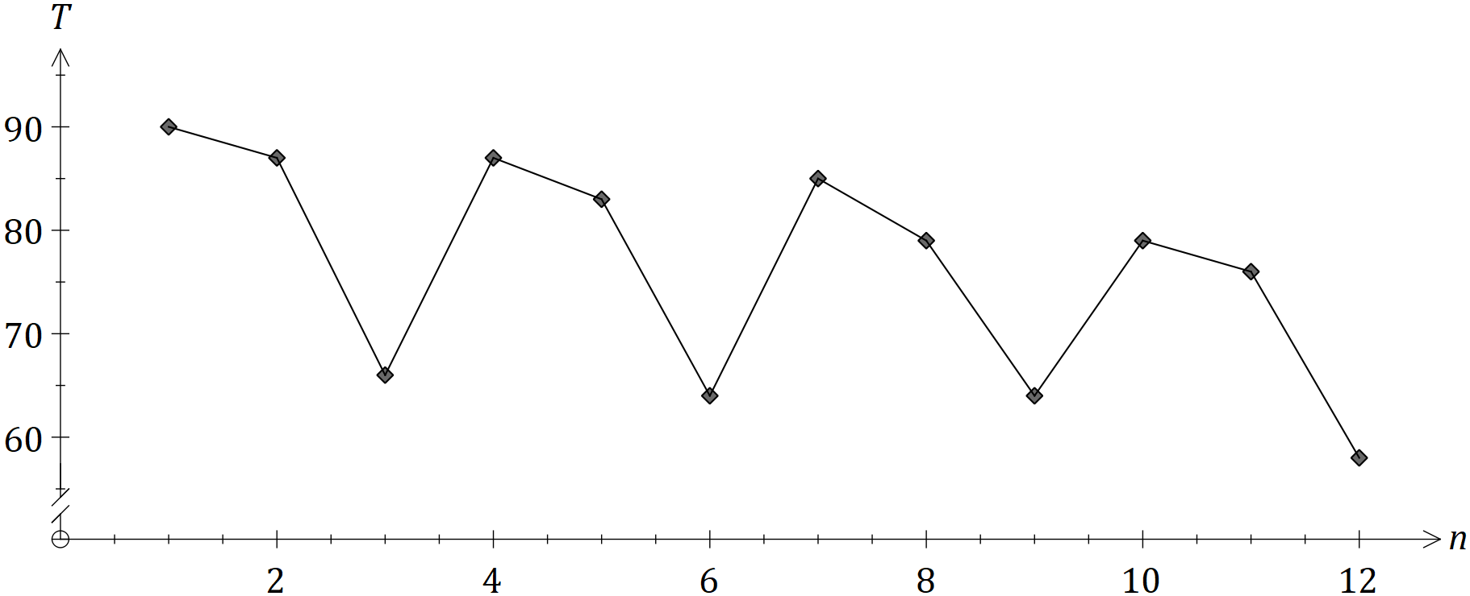

(a) Calculate the values of the entries A, B and C in the table. (3 marks)

(b) Complete the Seasonal Index table below. (2 marks)

|  |  |  |  |
| --- | --- | --- | --- |
| Day | Fri | Sat | Sun |
| Seasonal Index | $$1.114$$ |  |  |

(c) Calculate $D$, the deseasonalised value of $T$ for Friday of Week $4$. (2 marks)

The equation of the least-squares line for $t$ against $n$ is $\hat{t}=83.0-1.001n$.

(d) Forecast the time $T$ that the driver will take on Friday of Week $5$ if the existing trend and seasonality continue. (3 marks)

Question 18 (7 marks)

A project requires the following $10$ activities to be completed.

|  |  |  |  |  |  |  |
| --- | --- | --- | --- | --- | --- | --- |
| Activity | Immediate predecessor(s) | Time (weeks) |  | Activity | Immediate predecessor(s) | Time (weeks) |
| $$A$$ | $$C, L$$ | $$13$$ |  | $$F$$ | $$E$$ | $$9$$ |
| $$B$$ | $$E$$ | $$29$$ |  | $$G$$ | $$C, L$$ | $$17$$ |
| $$C$$ | $$\text{None}$$ | $$20$$ |  | $$H$$ | $$\text{None}$$ | $$8$$ |
| $$D$$ | $$A, F$$ | $$21$$ |  | $$K$$ | $$G$$ | $$15$$ |
| $$E$$ | $$\text{None}$$ | $$23$$ |  | $$L$$ | $$H$$ | $$14$$ |

(a) The network below represents the interdependencies of the above activities. Clearly label each edge with its activity and time. (3 marks)

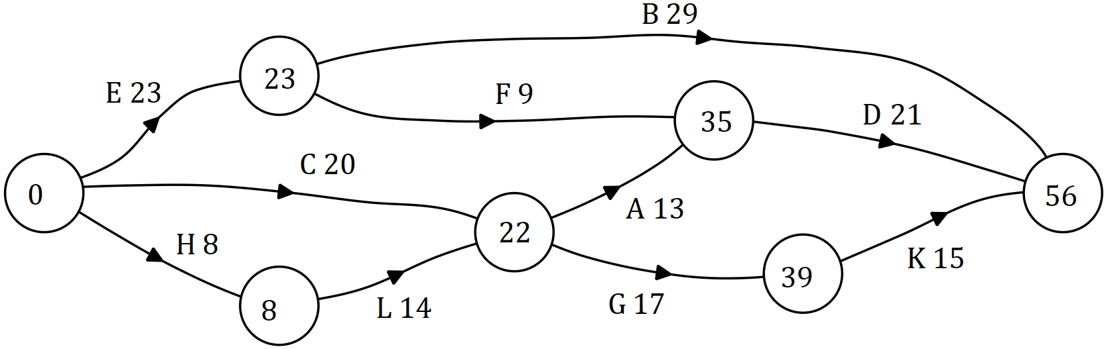

(b) Identify the critical path and hence state the minimum time for the project to be completed. (2 marks)

(c) Determine the latest start time and float time for activity $F$. (2 marks)

Question 19 (9 marks)

A business loan of $\$120 000$ was taken out at the start of the first quarter of 2018. Interest, at a rate of $13.8\%$ per annum, was calculated on the balance of the loan on the last day of each month and added to the loan. Repayments of $\$12 410.64$ were made on the last day of each quarter, just after interest for the month was added.

(a) Calculate the interest added during the first quarter of 2018. (3 marks)

(b) Determine

(i) the balance of the loan at the start of the second quarter of 2018. (1 mark)

(ii) the number of repayments to fully repay the loan. (1 mark)

(iii) the total interest charged over the life of the loan, to the nearest dollar. (2 marks)

(c) The business decided to halve the loan repayments, assuming that it would take twice as long to repay the loan. Write a brief note to the business commenting on the validity of this assumption. (2 marks)

Supplementary page

Question number: _________

Supplementary page

Question number: _________

© 2018 WA Exam Papers. Kennedy Baptist College has a non-exclusive licence to copy and communicate this document for non-commercial, educational use within the school. No other copying, communication or use is permitted without the express written permission of WA Exam Papers. SN245-126-4.